Lab 6 : Dynamic Routing Configurations : RIP, EIGRP, OSPF, BGP
Objectives :
- Grasp how routers automatically discover remote networks and maintain routing tables without manual entry of every path.
- Configure and analyse the operation of RIP, EIGRP, OSPF, and BGP, focusing on how different algorithms (Distance Vector, Link-State, and Path Vector) automatically discover network topologies and populate routing tables.
Theory :
Rather than requiring an administrator to manually configure every path, dynamic routing protocols enable routers to learn about remote networks on their own and maintain up-to-date routing tables automatically. A key advantage over static routing is the ability of these protocols to detect and respond to changes in network topology in real time, eliminating the need for human intervention whenever a link or router goes down.
1. Routing Information Protocol (RIP) :
Among the earliest distance vector protocols still in use, RIP is well known for its straightforward configuration, though it becomes impractical as network size grows.
- Algorithm: Uses the Distance Vector algorithm.
- Metric: Uses Hop Count to determine the best path, with a maximum limit of 15 hops.
- Operation: Routers send their entire routing table to their neighbours every 30 seconds.
- Versions: RIP v1 is classful (no subnetting support), while RIP v2 is classless and supports CIDR.
Network Topology :
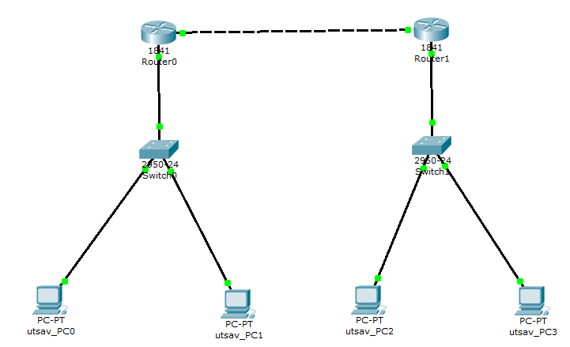

Configuration :
For PCs :
Device | IPv4 address | Subnet Mask | Default Gateway
utsav_PC0 | 192.168.1.2 | 255.255.255.0 | 192.168.1.1
utsav_PC1 | 192.168.1.3 | 255.255.255.0 | 192.168.1.1
utsav_PC2 | 192.168.2.2 | 255.255.255.0 | 192.168.2.1
utsav_PC3 | 192.168.2.3 | 255.255.255.0 | 192.168.2.1

For Routers :
Device | IPv4 address | Subnet Mask | Next Hop | Ethernet  Cable | Default Gateway
Router 0 | 192.168.2.0 | 255.255.255.0 | 10.0.0.2 | gig 0/0 | 10.0.0.1
 |  |  |  | gig 0/1 | 192.168.1.1
Router 1 | 192.168.1.0 | 255.255.255.0 | 10.0.0.1 | gig 0/0 | 10.0.0.2
 |  |  |  | gig 0/1 | 192.168.2.1

Commands :
Router 0 : Router 1 : router rip router rip version 2 version 2
network 192.168.1.0 network 192.168.2.0 network 10.0.0.0 network 10.0.0.0 no auto-summary no auto-summary

Observation :
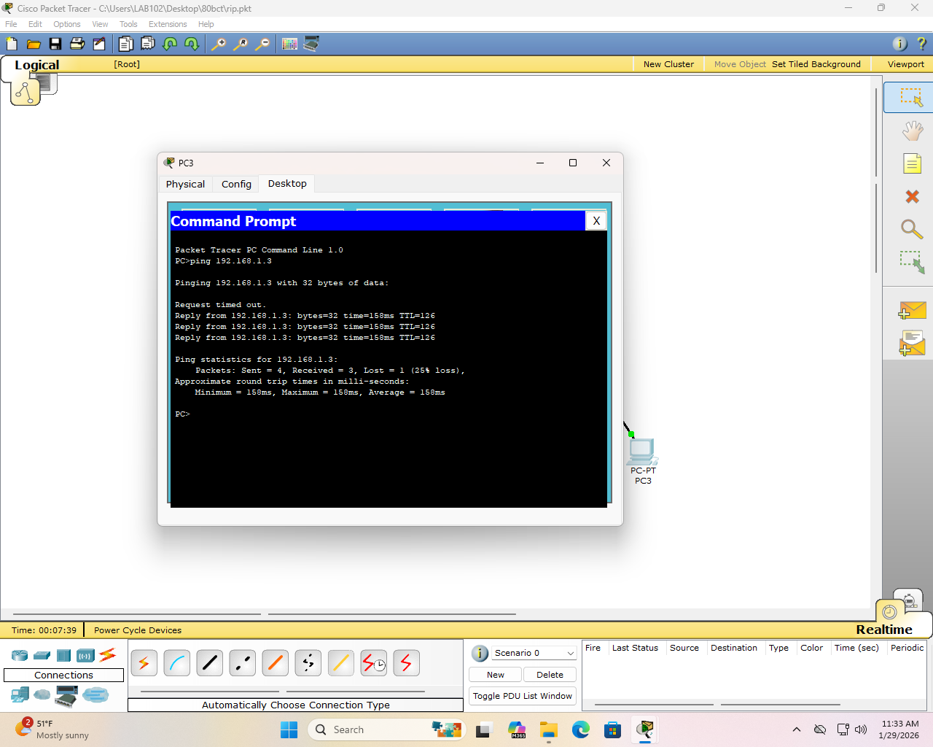

- Enhanced Interior Gateway Routing Protocol (EIGRP) :
EIGRP is considered a hybrid routing protocol, drawing on the characteristics of both distance vector and link-state approaches to deliver improved performance and reliability.
  - Algorithm: Uses the Diffusing Update Algorithm (DUAL) to ensure loop-free paths.
  - Metric: Uses a composite metric based on Bandwidth and Delay (optionally Reliability and Load).
  - Operation: Routers only send updates when a topology change occurs, which saves bandwidth.
  - Feature: Supports unequal cost load balancing, which is unique among these protocols.

Network Topology :


Configuration :
For PCs :
Device | IPv4 address | Subnet Mask | Default Gateway
utsav_PC0 | 192.168.1.2 | 255.255.255.0 | 192.168.1.1
utsav_PC1 | 192.168.1.3 | 255.255.255.0 | 192.168.1.1
utsav_PC2 | 192.168.2.2 | 255.255.255.0 | 192.168.2.1
utsav_PC3 | 192.168.2.3 | 255.255.255.0 | 192.168.2.1

For Routers :
Device | IPv4 address | Subnet Mask | Next Hop | Ethernet  Cable | Default Gateway
Router 0 | 192.168.2.0 | 255.255.255.0 | 10.0.0.2 | gig 0/0 | 10.0.0.1
 |  |  |  | gig 0/1 | 192.168.1.1
Router 1 | 192.168.1.0 | 255.255.255.0 | 10.0.0.1 | gig 0/0 | 10.0.0.2
 |  |  |  | gig 0/1 | 192.168.2.1

Commands :
Router 0 : Router 1 :
router eigrp 100 router eigrp 100
network 192.168.1.0 0.0.0.255 network 192.168.2.0 0.0.0.255 network 10.0.0.0 0.0.0.255 network 10.0.0.0 0.0.0.255
no auto-summary no auto-summary
Observation :
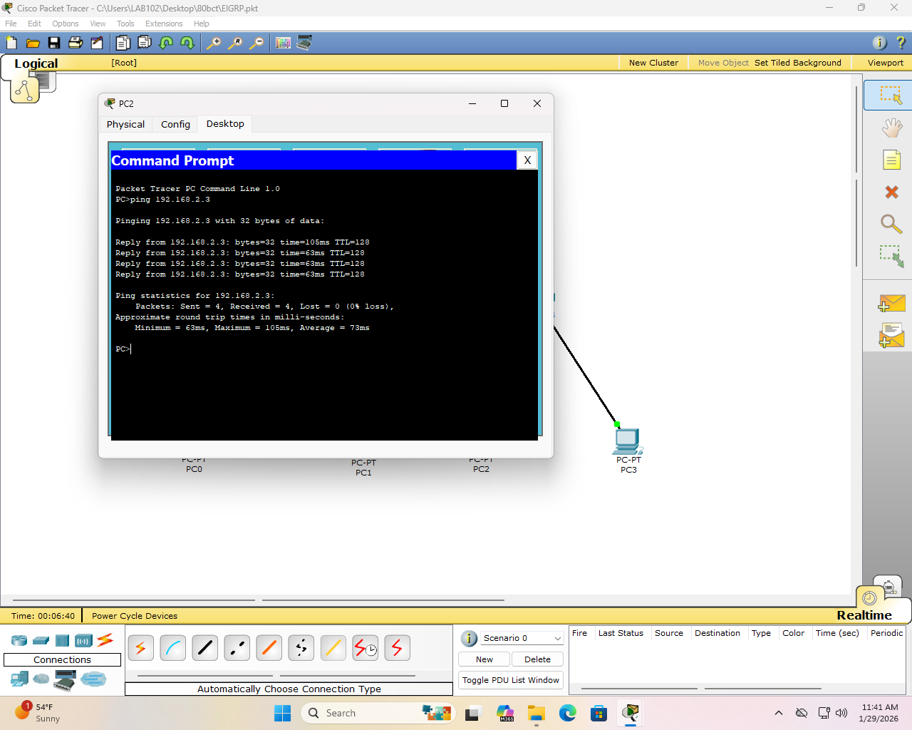

- Open Shortest Path First (OSPF) :
OSPF is an industry-standard link-state protocol engineered to support large-scale networks while achieving rapid convergence after topology changes.
  - Algorithm: Uses Dijkstra’s Shortest Path First (SPF) algorithm.
  - Metric: Uses Cost, which is calculated based on reference bandwidth divided by interface bandwidth.
  - Operation: Routers discover neighbors using "Hello" packets and exchange Link State Advertisements (LSAs) to build a synchronized topology database.
  - Advantage: Offers very fast convergence compared to RIP.
Network Topology :


Configuration :
For PCs :
Device | IPv4 address | Subnet Mask | Default Gateway
utsav_PC0 | 192.168.1.2 | 255.255.255.0 | 192.168.1.1
utsav_PC1 | 192.168.1.3 | 255.255.255.0 | 192.168.1.1
utsav_PC2 | 192.168.2.2 | 255.255.255.0 | 192.168.2.1
utsav_PC3 | 192.168.2.3 | 255.255.255.0 | 192.168.2.1

For Routers :
Device | IPv4 address | Subnet Mask | Next Hop | Ethernet  Cable | Default Gateway
Router 0 | 192.168.2.0 | 255.255.255.0 | 10.0.0.2 | gig 0/0 | 10.0.0.1
 |  |  |  | gig 0/1 | 192.168.1.1
Router 1 | 192.168.1.0 | 255.255.255.0 | 10.0.0.1 | gig 0/0 | 10.0.0.2
 |  |  |  | gig 0/1 | 192.168.2.1

Commands :
Router 0 : Router 1 :
router ospf 1 router ospf 1
network 192.168.1.0 0.0.0.255 area 0 network 192.168.2.0 0.0.0.255 area 0 network 10.0.0.0 0.0.0.255 area 0 network 10.0.0.0 0.0.0.255 area 0
Observation :
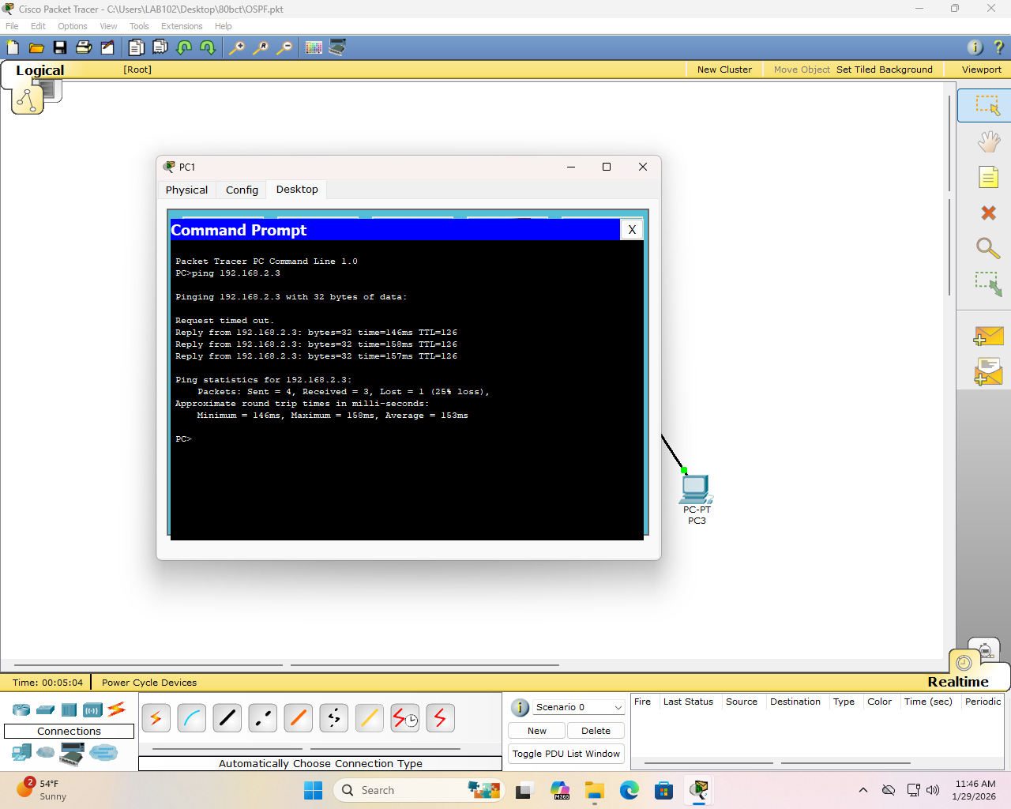
- Border Gateway Protocol (BGP) :
Operating as a path vector protocol, BGP serves as the backbone of inter-domain routing and is widely regarded as the core routing protocol that keeps the global internet functioning.
  - Purpose: It is used to connect different Autonomous Systems (AS), which are groups of networks under a single administration.
  - Operation: BGP uses path attributes (like AS-Path) rather than simple metrics to select the best path.
  - Reliability: It uses TCP port 179 for reliable communication between routers.
  - Scalability: It is highly reliable and scales to manage the entire global internet routing table.
Network Topology :


Configuration :
For PCs :
Device | IPv4 address | Subnet Mask | Default Gateway
utsav_PC0 | 192.168.1.2 | 255.255.255.0 | 192.168.1.1
utsav_PC1 | 192.168.1.3 | 255.255.255.0 | 192.168.1.1
utsav_PC2 | 192.168.2.2 | 255.255.255.0 | 192.168.2.1
utsav_PC3 | 192.168.2.3 | 255.255.255.0 | 192.168.2.1

For Routers :
Device | IPv4 address | Subnet Mask | Next Hop | Ethernet  Cable | Default Gateway
Router 0 | 192.168.2.0 | 255.255.255.0 | 10.0.0.2 | gig 0/0 | 10.0.0.1
 |  |  |  | gig 0/1 | 192.168.1.1
Router 1 | 192.168.1.0 | 255.255.255.0 | 10.0.0.1 | gig 0/0 | 10.0.0.2
 |  |  |  | gig 0/1 | 192.168.2.1

Commands :
R0 - AS 65001
R1 - AS 65002

Router 0 : |  | Router 1 :
router bgp 65001 |  | router bgp 65001
neighbor 10.0.0.2 remote-as 65002 |  | neighbor 10.0.0.1 remote-as 65001
network 192.168.1.0 mask 255.255.255.0 |  | network 192.168.2.0 mask 255.255.255.0
Observation :
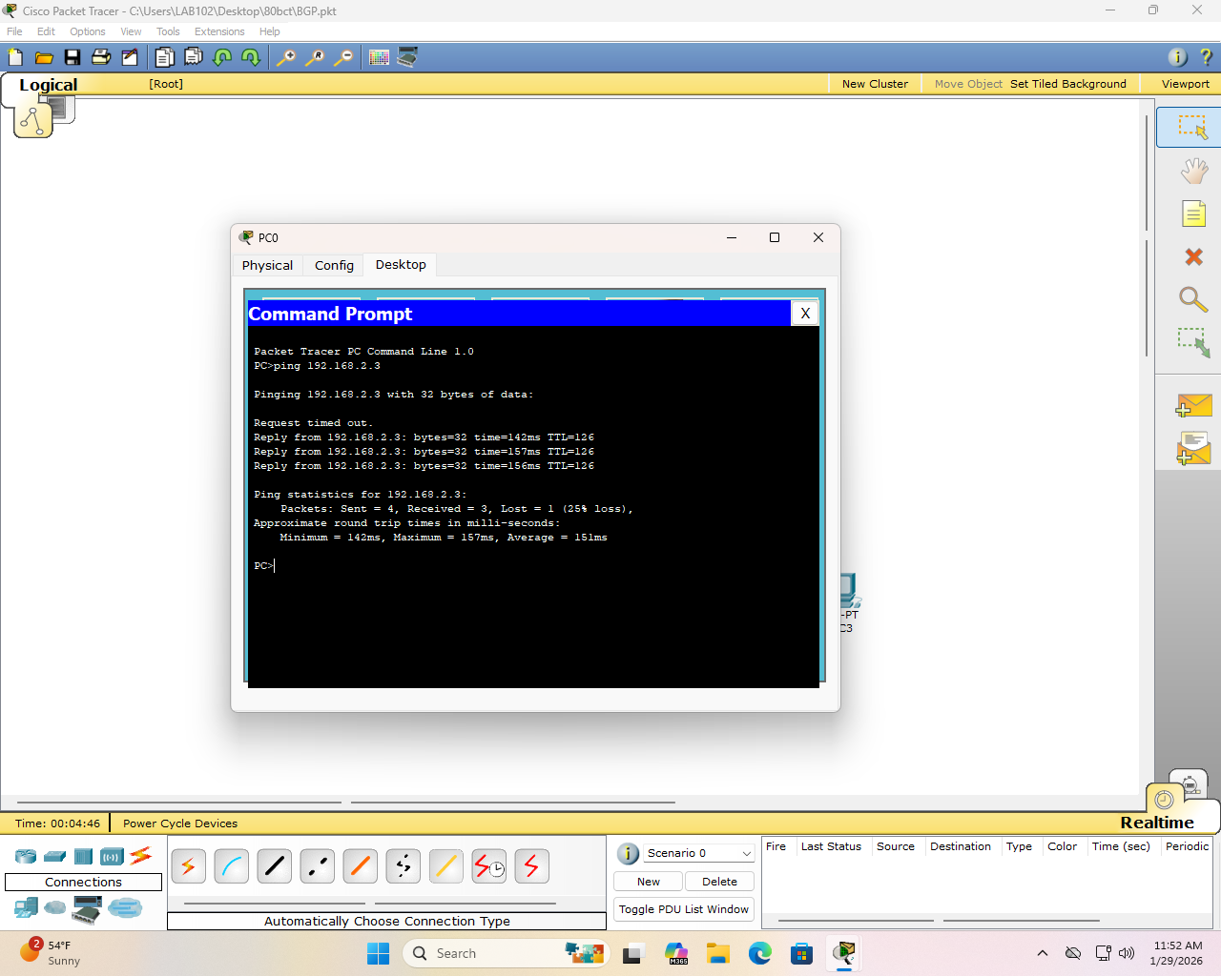
Result:
Dynamic routing was implemented using RIP, EIGRP, OSPF, and BGP. After configuration, routers automatically exchanged routing information and learned network paths. Routing tables confirmed successful route discovery, and ping tests verified end-to-end connectivity between hosts.

Discussion:
Four dynamic routing protocols were analyzed. RIP was simple but limited because it uses only hop count. OSPF used bandwidth-based cost for better path selection in larger networks. EIGRP showed faster convergence due to the DUAL algorithm. BGP demonstrated inter-AS routing using path attributes like AS-Path. Network connectivity was verified using ping commands.

Conclusion:
Hence, the lab provided practical experience configuring RIP, EIGRP, OSPF, and BGP.

